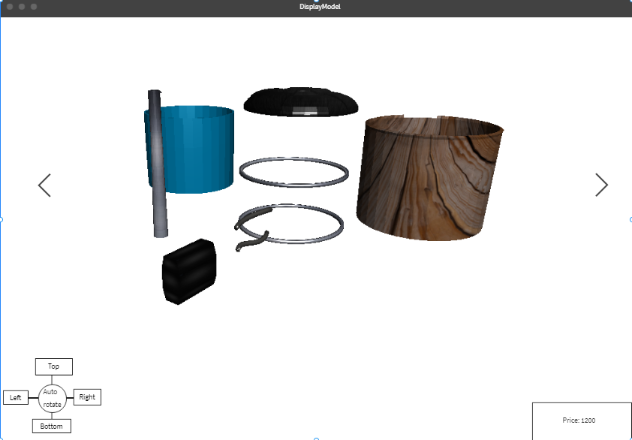

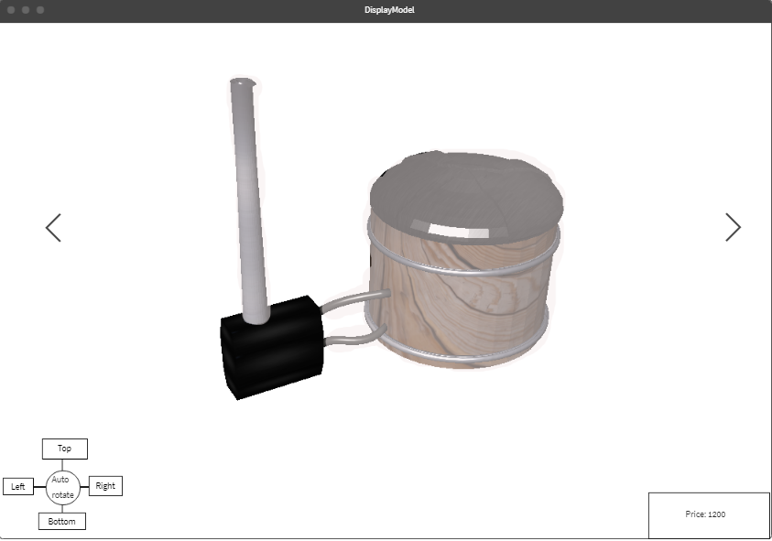

Initially default model will be displayed as separate objects. Animation will be added for showing users the ability to separate object by mouse. User slide left or right to change the model from default model.

When users hover mouse on an object, all the other object will be blurred to show the selected object.

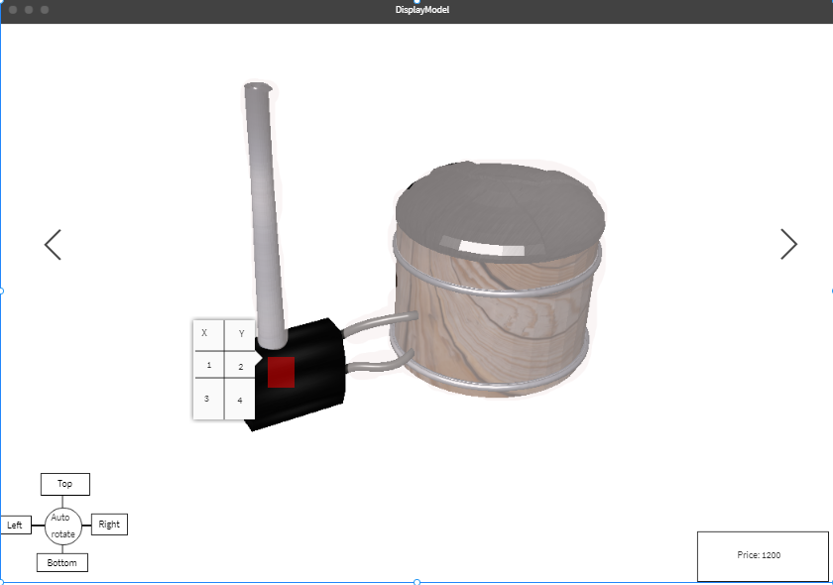

Users can add a point/area. A pop up with keys/values table will be displayed to show users that their modification is pending and has been added to the model. These point/area will act as a button so users can click on it to trigger opening the table to edit and add their desired modification. If the user has an image of the object that they wanted, they can add to the table of keys/values. These point/area will be visible as other object in the model and only disappeared after the developer has finish modeling the new object according to users desired.

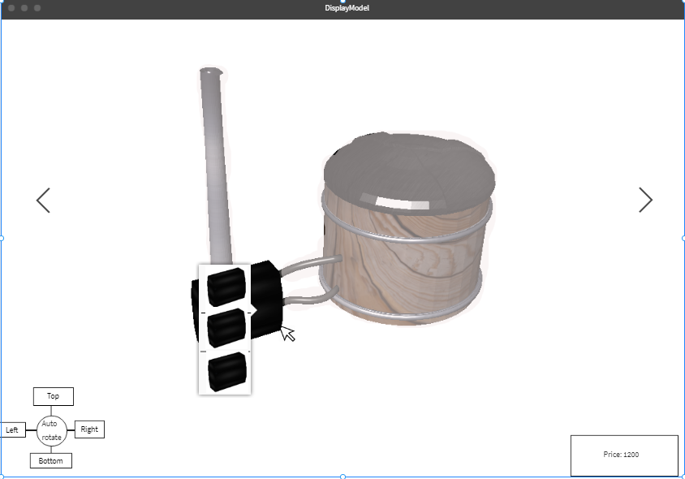

Out of the point/area, the rest of the selected object will be clickable, which trigger opening the list of ready-made, available options for the selected object.